MACH4METAL

metalworking machinery
Transito 21, 6909 DA Babberich, Netherlands
Tel. + 31 (0)316 – 247123
Fax. + 31 (0)316 - 247956

Bank No : 66.52.13.883
IBAN : NL33 INGB 0665 2138 83
BIC : INGBNL2A
VAT : NL 815393635B01

FEHLMANN Picomax 60 M

- Make : Fehlmann Swiss
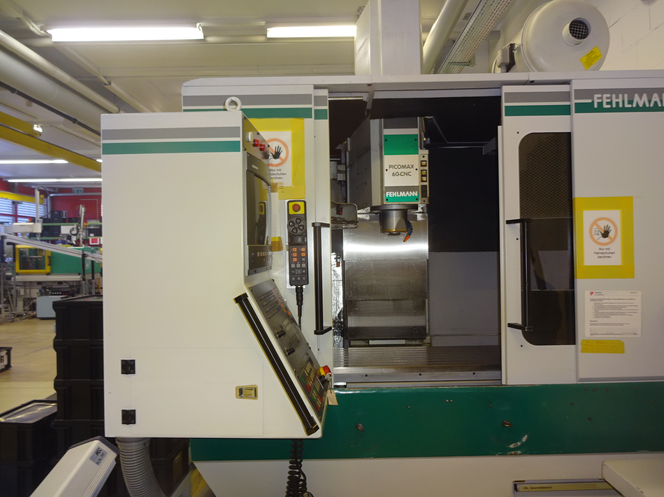
- Type : PICOMAX P60M
- YOP :
- Serial : 151 95 263

- Capacity working area
- X travel : 500 Rapid 20.000
- Y travel : 350 Rapid 20.000
- Z travel : 610 Rapid 20.000

- Table length : 920
- Table width : 380
- Load : 250
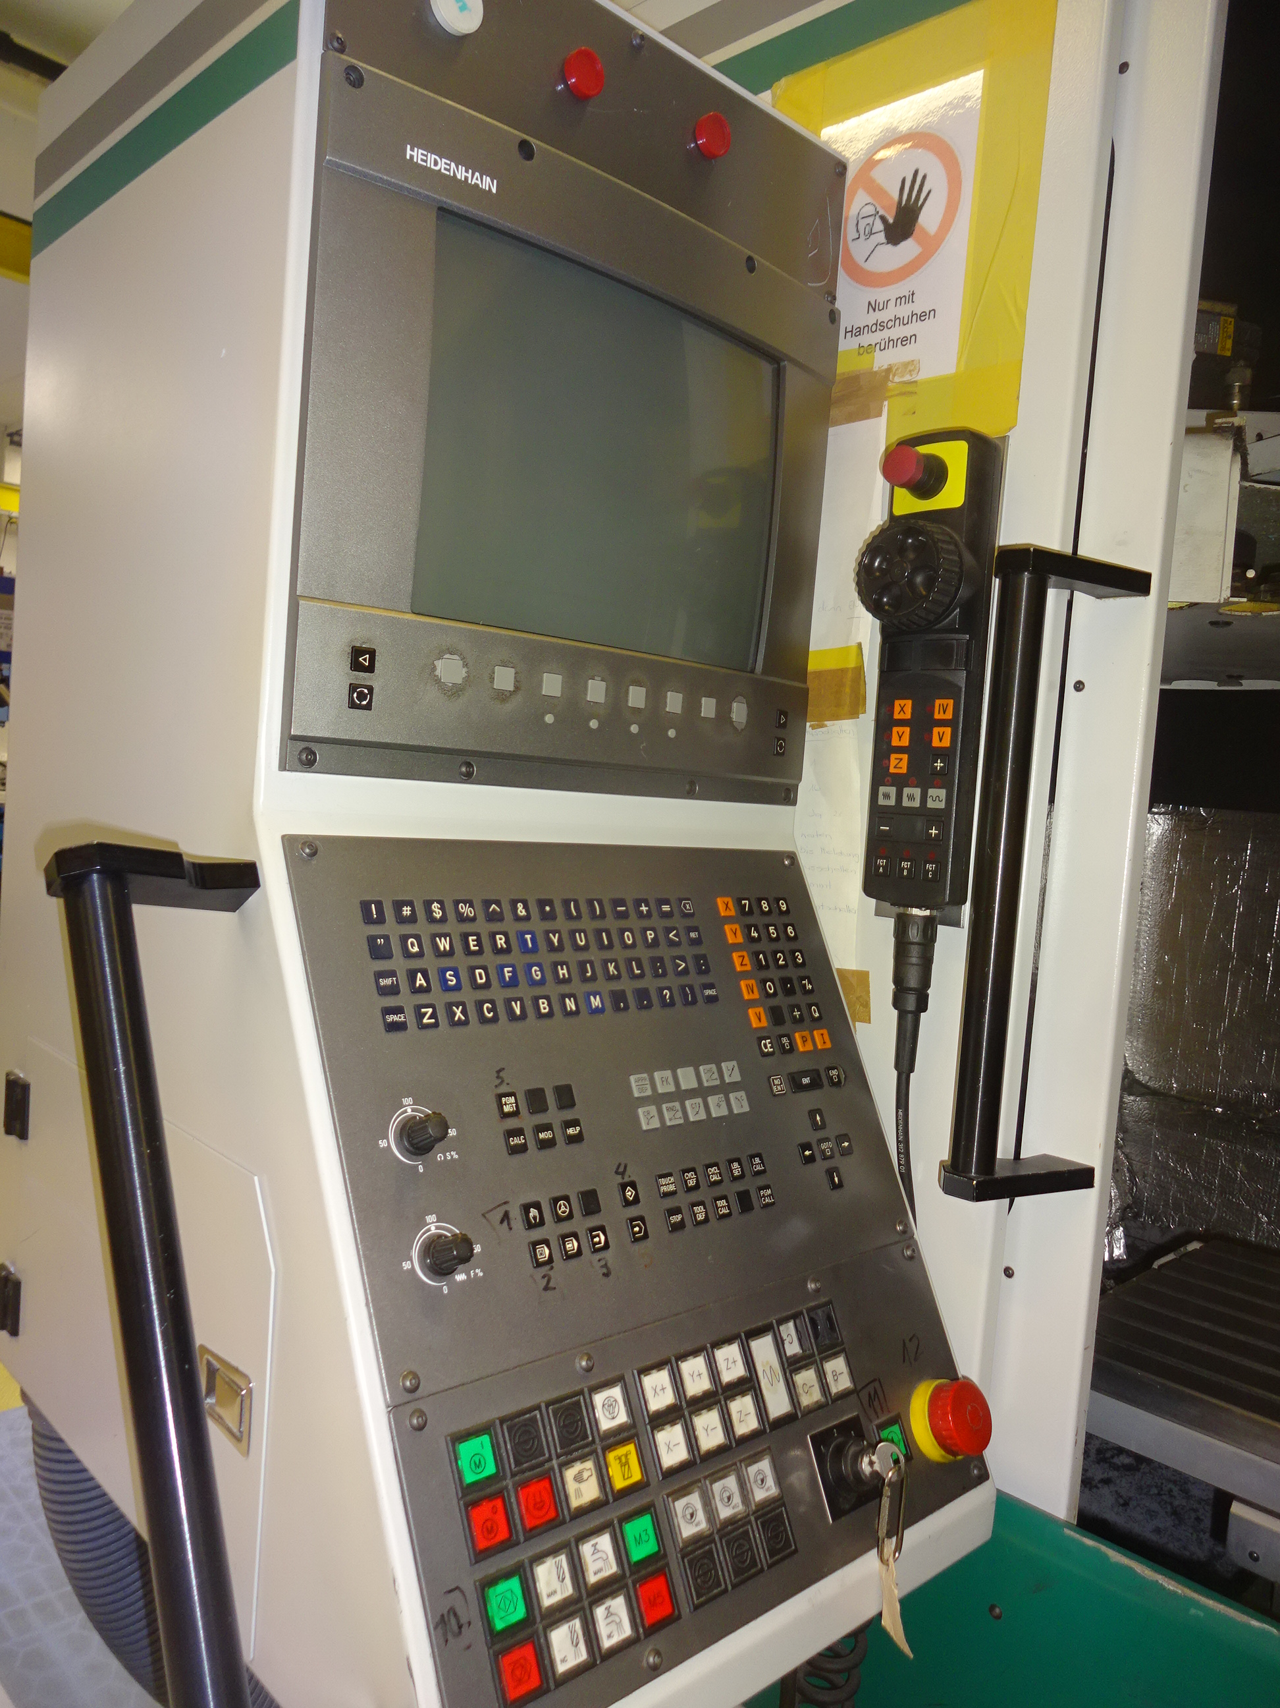

- Spindle taper : Sk 30
- Speed range : 18.000
- Spindle power : 10 kW

- Min. table to spil : 94
- Max. table to spil : 704
- Horizontal throat : 405

- Drilling steel : 30
- Milling : 100 cm³
- Tapping : M 24

- Tool changer 24 positions
- Dr. HeidenHain TNC 426

- Dimensions
- Length : 3400
- Width : 2800
- Height : 2900
- Weight : 5000

Please Note: The above information has been obtained to the best of our ability and belief from, and from the manufacturers where possible. It is given in good faith, but its accuracy can not be guaranteed. Accordingly, it will not form a representation or constitute contractual terms. We advise you to check any vital details!

